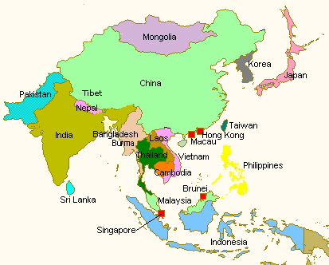

**Asia Day**

President’s Day Open House

February 16, 2015

Gish Theatre Hanna Hall  
Sponsored by: Asian Studies Program

Ongoing Activities



Calligraphy (shodo)

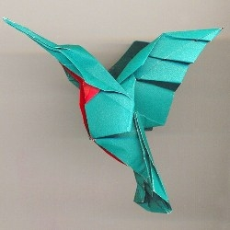 [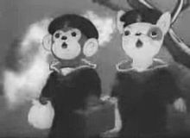](http://en.wikipedia.org/wiki/File:Momotaro's_Divine_Sea_Warriors-screeny.JPG)

Origami Anime

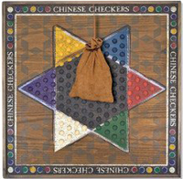

Games

* Meet with the current BGSU Asian Studies Majors and Minors
* Asian Snacks

Asia Day Itinerary

**9:30 AM**

**Assembly for Students & Faculty**

* Introduction of faculty and current Asian Studies students
* Asian Studies Program Information
* Study Abroad/Scholarships

**Introduction of Language Studies**

* Chinese
* Japanese
* Korean

**Introduction of Clubs**

* Japanese Club
* Chinese Club
* Korean Club
* Performance of Martial Arts & Taiko

