Joshua Drouillard
ARTC 4180
Self-Assessment Essay
An artist finding their calling is a life long journey. The path is constantly in flux and building upon steps one takes every day. Since I began my journey as an artist I have built upon my interests and skillset and have jumped from various styles. When I began at BG, I was unsure how to define myself as an artist. A few years have passed and although my journey is far from over, I can now say I am getting better at defining the kind of artist I am and aspire to be.
My primary medium of digital art is 3D modeling. My focus from a technical standpoint has been to produce 3D assets designed for game development. The skills that I have acquired through this specialization have been modeling, sculpting, retopology, UV Mapping, texturing and animation. I aim for all my models to be representative of the larger project they belong to in their design and to use subtle details that aid in the narrative of the overall project.
My favorite work is often either mechanical or related to anatomy in nature. This is because I find subjects most visually interesting when upon viewing, they inspire wonder in terms of how they work. When developing concepts for objects to model it is important to me to consider function and how the object would work if it existed non-digitally. My interest in functionality leads to my interests conceptually which are largely the ideas of industry and nature. Objects in nature always have a function just as objects that are human made. How nature and industry clash and work together are fascinating topics that I like to explore in my art. I am also conceptually interested in logic and philosophical arguments. In some of my past work I’ve explored the existence of an all-powerful deity and the different relationships humanity has towards them if they exist. I like to answer grand questions with answers that are open-ended yet relatable to tangible experiences.
I often find stylization to be the more visually intriguing method to communicate with my art, however if the piece I’m working on would be stronger if it more closely resembled real-life, that is what I will aim for. This is to say; my style adapts depending the theme of the project. As an artist I hope to improve my technical skills to a point where I can develop characters, vehicles and objects that are fantastical, but take inspiration from the visual complexities of objects in the physical world, both human-made and organic.
An artist that I find makes work related to my own would be Nicholas Cort. Nicholas creates many character and creature designs that exaggerate the function of the subject. The robotic designs that Cort works with all have a function that visually represented in their design. Likewise, Cort’s creature designs feature characteristics that visually distort anatomical features to provide information about the animal. Nicholas’ work incites imagination and inspiration to function. Additionally, Nicholas Cort is an incredible 3D sculpture. While I have not yet reached the capability to sculpt at the level of detail that he does, his work serves as some motivation for me to improve.
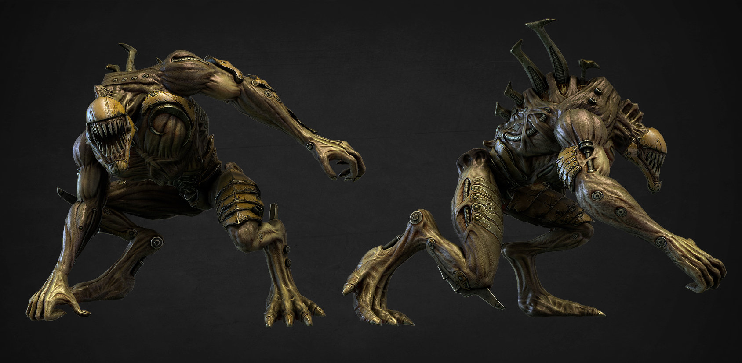
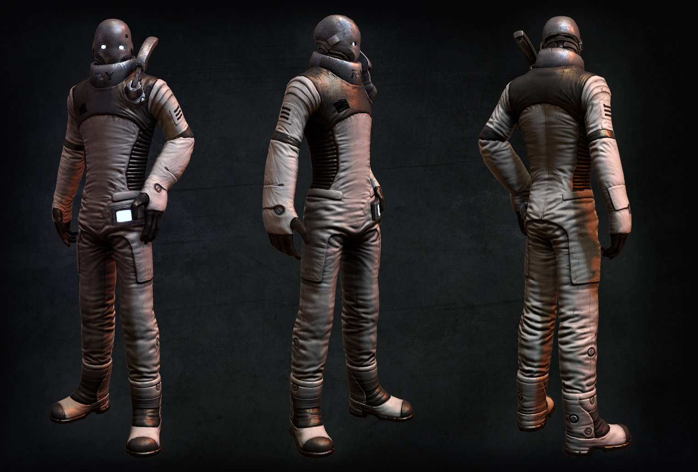
My time at BG has brought about some of the most significant changes in my art. I have an area of focus in medium and concept, though each is subject to change with each passing work that I construct. As my journey continues I know my art will continue to evolve with my values and interests.

