**Game Concept**: I am aiming to create a somber emotional experience through this game. The main focus of the gameplay experience will be the story. Following closely behind in priority, and part of the responsibility for the somber atmosphere will be the visuals. I am creating sprite work for the game, the characters being entirely sprites. The setting of the game will be created via a hybrid of 3d models and sprite work. The gameplay itself is going to be side-scrolling with a simple combo system with on the ground combos, launchers, and some aerials for combat.

**Story:** The story begins with two friends enlisted in an old European military arriving by boat to a snowy, bleak country and moving to occupy it. The player character (name option) and their best friend Kris express doubt in the operation but have not much of a choice in the matter of the military. As is often the case, the occupation turns violent, and the two friends are forced to go to war over the country. (**Spoiler territory begins**) As the war goes on and the player character is forced to kill, their mind reaches a breaking point. As a justification for the killing of innocents, women and children, the player character’s mind begins to see them as literal demons. As the war rages on, the player character’s mind suffers a steady degradation, believing an actual descent into hell has occurred. The final demon is a difficult battle that the player will ultimately lose. At that point there is a snap back to reality as it is revealed that the final opponent was the player character’s friend Kris. He stays with the player character as they die in his arms.

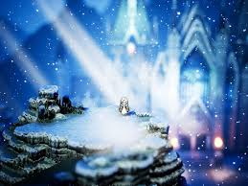**Inspirations:**

Octopath Traveler: Stylistically very similar

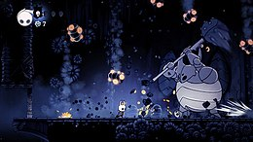Hollow Knight: Bleak feeling, simple platforming and combat

