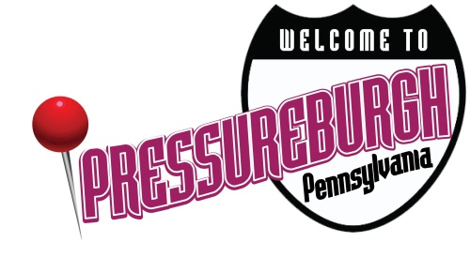
Moving Your Way to Lower Blood Pressure!

Having high blood pressure puts you at risk for heart disease and stroke, the leading causes of death in the United States. Fortunately, it is mostly preventable! Along with consuming a healthy diet, exercise can help lower blood pressure. Any amount of physical activity, even low-intensity exercise such as walking, can lower your blood pressure. To significantly improve your blood pressure and health, aim to accumulate 150 minutes of moderate-intensity exercise each week.

Consistency is the key! To keep your blood pressure low, you need to keep exercising. It takes about one to three months for regular exercise to have an impact on your blood pressure. The benefits last only as long as you continue to exercise. Mix up your routine to prevent boredom and find activities you enjoy doing so you are more likely to stick with it!

Short and Sweet Cardio Circuit!
Stuck inside? Short on time? No worries – complete this short at-home cardio circuit to enhance your cardiovascular health and lower your blood pressure. Begin by completing two sets of the following warm-up exercises:
Warm-up Exercises | Time | Description
Arm Circles  (Front and Back) | 15 seconds forward  15 seconds backward | Big circle motions forward and backwards with your arms
High Steps with grabbing of the knee on top | 30 seconds | Bring knee up to the chest and gently grab your knee with both hands to pull it into your body. Repeat on opposite side.
Torso Rotations with Knee Raises | 30 seconds | Raise your arms, then lift left knee and bring right elbow down to meet it. Repeat on opposite side and gradually increase the pace.
Boxer Shuffle | 30 seconds | Stay on your toes and move feet side to side

Now you are ready to begin your aerobic activity! Complete each exercise for one minute. Rest 15-30 seconds before completing the next exercise listed. Complete one to three sets of the circuit, depending on your fitness level and time availability.

Aerobic Exercises | Time | Description
Jogging in place or High Knees | 1 minute | Either jog in place while pumping your arms or alternate drawing your knees up to your waist.
Jumping Jacks | 1 minute | Stand with feet together, knees slightly bent, and arms to sides. Jump while raising arms overhead and separating legs to sides. Return to start position and repeat.
Alternating Lunges | 1 minute | With your core tight and shoulders rolled back, lunge forward with first leg. Land on heel then forefoot. Lower body by flexing knee and hip of front leg until knee of rear leg is almost in contact with floor. Return to standing and repeat lunge with opposite leg.
Body Weight Squats | 1 minute | Stand with arms extended forward. Squat down as if sitting in a chair, keeping back straight and knees pointed same direction as feet. Lower until thighs are just past parallel to floor. Return to start position and repeat. Keep your back straight and chest high.
Line Hops or Steps | 1 minute | Step or hop sideways over a line on the ground. Move as quickly as you can side to side.
Speed Skaters | 1 minute | Stand with feet hip-width apart, arms by sides. Hop to right, landing on right foot while sweeping left foot diagonally behind right leg and swinging left arm across body and right arm behind back. Jump to left, switching legs and arms to complete 1 rep.
Rest and repeat circuit one or two more times!

Great work! Now you are ready for the cool-down. Hold each exercise for 20-30 seconds and complete one to two sets.

Cool-down Stretches | Description
Quadricep Stretch | While standing, bring your heel up towards your butt. Grasp your shin or ankle and hold. Use a wall or something for support if needed. Repeat on other leg.
Hamstring Stretch | Sit on floor with legs extended. Maintain straight back while reaching toward toes (even if you can’t touch them); hold.
Calf Stretch | Stand 10 inches away from a wall; place palms on it. Step back with right foot. Bend left knee, keep right heel down and hold. Repeat on opposite side.
Chest Stretch | Stand up tall, lengthening through the spine. Lift your chest, and relax your shoulders. Look straight ahead, keeping your chin level. Clasp your hands behind your back, and slowly raise arms as far as possible. Hold and breathe naturally.

